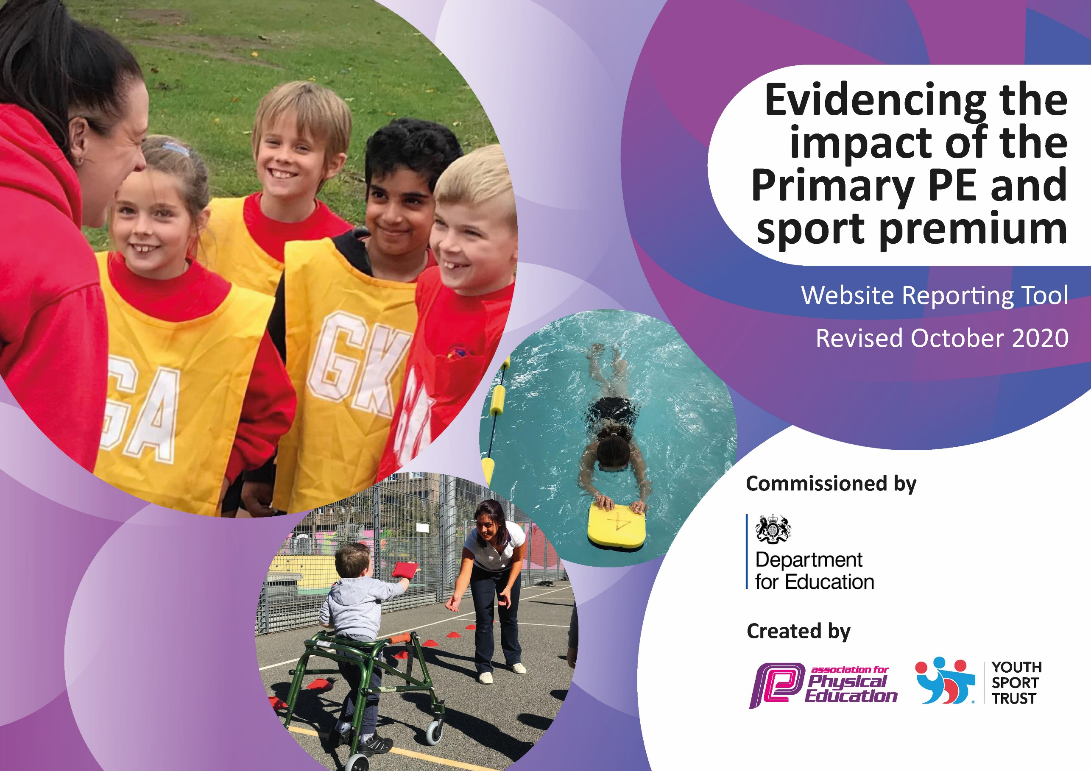
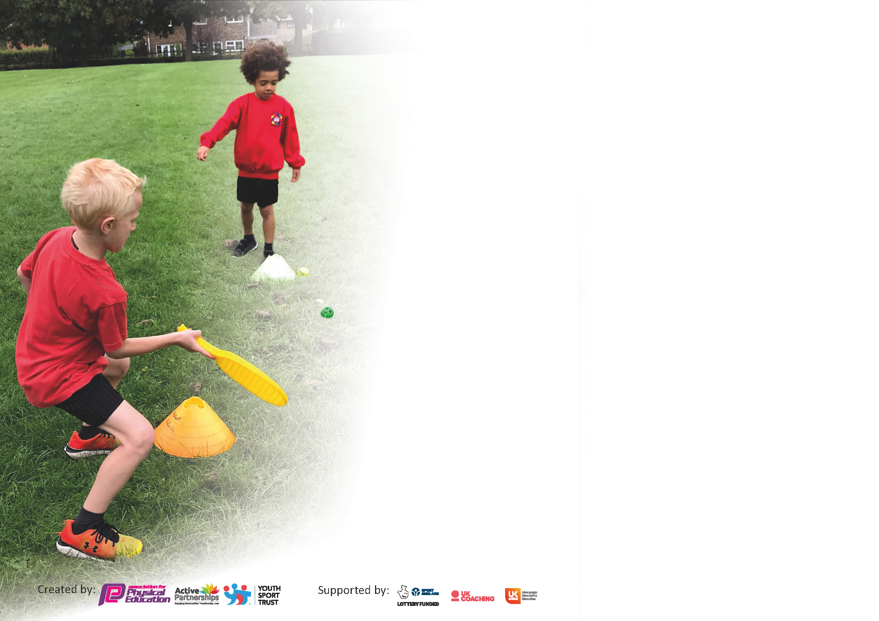

It is important that your grant is used effectively and based on school need. The Education Inspection Framework (Ofsted 2019 p64) makes clear there will be a focus on ‘whether leaders and those responsible for governors all understand their respective roles and perform these in a way that enhances the effectiveness of the school’.

Under the Quality of Education criteria (p41) inspectors consider the extent to which schools can articulate their curriculum (INTENT), construct their curriculum (IMPLEMENTATION) and demonstrate the outcomes which result (IMPACT).

To assist schools with common transferable language this template has been developed to utilise the same three headings which should make your plans easily transferable between working documents.

Schools must use the funding to make additional and sustainable improvements to the quality of Physical Education, School Sport and Physical Activity (PESSPA) they offer. This means that you should use
the Primary PE and sport premium to:

- Develop or add to the PESSPA activities that your school already offer
- Build capacity and capability within the school to ensure that improvements made now will benefit pupils joining the school in future years

Please visit gov.uk for the revised DfE guidance including the 5 key indicators across which schools should demonstrate an improvement. This document will help you to review your
provision and to report your spend. DfE encourages schools to use this template as an effective way of meeting the reporting requirements of the Primary PE and sport premium.

We recommend you start by reflecting on the impact of current provision and reviewing the previous spend.

Schools are required to publish details of how they spend this funding as well as on the impact it has on pupils’ PE and sport participation and attainment by the end of the summer term or by 31st July 2021 at the latest.

** In the case of any under-spend from 2019/20 which has been carried over this must be used and published by 31st March 2021.

We recommend regularly updating the table and publishing it on your website throughout the year. This evidences your ongoing self-evaluation of how you are using the funding to secure maximum, sustainable impact. Final copy must
be posted on your website by the end of the academic year and no later than the 31st July 2021. To see an example of how to complete the table please click HERE.
Created by: Supported by:

Please note: Although there has been considerable disruption in 2020 it is important that you publish details on your website of how you spend the funding - this is a legal requirement.
Support for review and reflection - considering the 5 key indicators from DfE, what development needs are a priority for your setting and your pupils now and why? Use the space below to reflect on previous spend and key achievements and areas for development.

N.B. In this section you should refer to any adjustments you might have made due to Covid-19 and how these will influence further improvement.
Key achievements to date until July 2020: | Areas for further improvement and baseline evidence of need:
- Achievement of AFPESS Quality Mark, Gold School Games Award and winners of the WASSP Award for ‘Promoting Physical Activity and Well-being’.  - 2. Implementation of the Daily Mile across all phases.  - 3. Healthy Body, Healthy Mind firmly established throughout the school with a two-week annual summer event that we still managed to provide remotely during lock down. In addition, we kept children active during lockdown by providing live challenges, using online resources such as Jo Wicks, Born to Move and Cosmic Yoga. We also held a virtual sports day and participated in our TCAT sports challenge during lockdown.  - 4. Born to Move well established within the classroom as well as at home and within bubbles in school during lock down.  - 5. Active lessons are happening across all phases, with teachers making use of the ‘Teach Active’ resources provided for English and Maths lessons, as well as other mindfulness activities such as yoga and meditation.  - 6. We participated in a high level of cluster competitions reaching the county athletics finals for the first time. We also competed in the Junior Cross Country Championships and for the first time our boys' team won bronze medal.  - 7. New kit secured through the Aldi Voucher Scheme.  - 8. Year 5/6 Real Leaders Festival for younger children was held for the first time.  - 9. Overhaul of our LTP in PE to ensure progression, consistency and high level provision of PE.  - 10. Introduction of our PE iPad to record progress in PE as well as the role out of Jasmine Real PE online planning resource. | - To recruit a new PE Apprentice and support PE lessons, lunch time activities and lead new areas of initiatives in PE.  - 2.To develop our relationship with Progressive Sport to start to include mindfulness, wellbeing and mental health to our PE curriculum.  - 3.To improve the monitoring of Teaching and Learning and support assessment through the use of PE iPad and #sankeysports on Twitter to record progression in PE.  - 4. To bridge the gap in fitness levels for those children that were completely inactive during lockdown and to also provide catch up swimming lessons for the current Year 5 who missed out being assessed in Year 4 due to lockdown.  - 5. To introduce Real Gym into our curriculum and provide CPD for staff.

If any funding from the academic year 2019/20 has been carried over you MUST complete the following section. Any carried over funding MUST be spent by 31 March 2021.
Academic Year: September 2020 to March 2021 | Total fund carried over: £10,000 | Date Updated:  November 2020
What Key indicator(s) are you going to focus on? |  |  |  | Total Carry Over Funding:
 |  |  |  | £
Intent | Implementation |  | Impact
Your school focus should be clear how you want to impact on your pupils.  To improve swimming provision for Year 4 and catch up for Year 5 who missed out on this year’s lessons. To use sessions at Penketh for swimming lessons for Year 5s to catch up (if it re-opens.)  To improve active play on the playground. | Make sure your actions to achieve are linked to your intentions:  To join Livewire Scheme at Great Sankey Hub for all Year 4s to attend a 45 min lesson for 10 weeks in either the Spring / Summer Term. Transport will be included to and from the pool. All Year 5s to be assessed to see if they meet the KS2 swimming requirements. Only those who don’t need to complete the addition sessions.  To install two four ball chutes with playground markings, two target boards to improve throwing and catching skills and replace netball court markings. | Carry over funding allocated:  £2500  £5083 (Pentagon)  £500 ( Geography) | Evidence of impact: How can you measure the impact on your pupils; you may have focussed on the difference that PE, SS & PA have made to pupils re-engagement with school. What has changed?  Unable to commence due to Penketh pool remaining closed and Great Sankey Hub having to catch up with the backlog from 2020. We are scheduled to commence in September 2021.  Meeting with Pentagon and they are now booked in on Monday 15th February to complete the work.  Ball chutes and playground markings installed during half term. It was decided that the ball targets were too big for our fence so we decided to install an orienteering course around our playground and playing field (contribution of £500 to the geography budget.) Children now actively using the ball chutes during PE lessons and breaks. | Sustainability and suggested next steps and how does this link with the key indicators on which you are focussing this academic year?:

Meeting national curriculum requirements for swimming and water safety.

N.B Complete this section to your best ability. For example you might have practised safe self-rescue techniques on dry land.
What percentage of your current Year 6 cohort swim competently, confidently and proficiently over a distance of at least 25 metres?  N.B. Even though your pupils may swim in another year please report on their attainment on leaving primary school at the end of the summer term 2020. | 90%
What percentage of your current Year 6 cohort use a range of strokes effectively [for example, front crawl, backstroke and breaststroke]? | 90%
What percentage of your current Year 6 cohort perform safe self-rescue in different water-based situations? | 95%
Schools can choose to use the Primary PE and sport premium to provide additional provision for swimming but this must be for activity over and above the national curriculum requirements. Have you used it in this way? | No but we will do this year.

Action Plan and Budget Tracking
Capture your intended annual spend against the 5 key indicators. Clarify the success criteria and evidence of impact that you intend to measure to evaluate for pupils today and for the future.

Academic Year: 2020/21 | Total fund allocated: £ | Date Updated:
Key indicator 1: The engagement of all pupils in regular physical activity – Chief Medical Officers guidelines recommend that primary school pupils undertake at least 30 minutes of physical activity a day in school |  |  |  | Percentage of total allocation:
 |  |  |  | 6%
Intent | Implementation |  | Impact
Your school focus should be clear what you want the pupils to know and be able to do and about  what they need to learn and to  consolidate through practice: | Make sure your actions to achieve are linked to your intentions: | Funding allocated: | Evidence of impact: what do pupils now know and what can they now do? What has changed?: | Sustainability and suggested next steps:
To bridge the gap for chn who may have been less active during lockdown, we have allocated 15 min each afternoon to physical activity, mindfulness and relaxation in addition to 45 minutes playtime and weekly PE lesson. Activities include the daily mile, Born to Move, yoga and meditation as well as Go Noodle' within maths and English lessons.  Investment in outdoor playground equipment (see roll over spend) will also be used to help engage more children at play and lunch times. | To ensure the timetable for the daily mile is adhered too and monitor the range of other activities each phase is implementing on a daily basis. Complete a heat map for each phase. | Born to Move Subscription £210 | A timetable has been collated for each phase to show which mindfulness activities are carried out each day. Observations made of children completing these activities as well as the daily mile  Meeting with Pentagon and they are now booked in on Monday 15th February to complete the work.  Whole school took part in Red Nose Day charity ‘Jerusalema’ dance which resulted in daily dance practise for two weeks and culminated with each class creating a video of the dance as well as all the staff also creating a video of the dance too!  All children took part in our ‘Road to Tokyo’ Sports Festival which allowed children from reception to Year 6 to experience handball, archery and hockey for the first time.  Our KS2 children also tried Quidditch for the first time which targets children who may not feel they are good at traditional team sports. The reaction from the children was amazing and we are now considering getting CPD training in September.
Key indicator 2: The profile of PESSPA being raised across the school as a tool for whole school improvement |  |  |  | Percentage of total allocation:
 |  |  |  | 25%
Intent | Implementation |  | Impact
Your school focus should be clear what you want the pupils to know and be able to do and about  what they need to learn and to  consolidate through practice: | Make sure your actions to achieve are linked to your intentions: | Funding allocated: | Evidence of impact: what do pupils now know and what can they now do? What has changed?: | Sustainability and suggested next steps:
To invest in Real Gym as a new programme to our curriculum and raise the profile and delivery of gymnastics.  To raise the profile of girl's football through FA Primary Teaching Award and Active Play through story telling.  To provide the best equipment, increase the range of PE resources to ensure high quality PE lessons can be delivered. To also order more sports kit for competitions. | PE team to do CPD Real Gym training and then roll out to the rest of the school.  PE Apprentice / Matt to complete the Active Play Through Story Telling & FA Primary Teaching Award.  To audit the PE cupboard and outdoor equipment and order / replace as required.  Order 2 sets of GSP PE kit for competitions. | £850 (£495 Jasmine &£350 day training)  Real Gym  £1500  WASSP Membership  £1500  Equipment | To be rolled forward to 2021-22 due to not being able to hold practical whole school CPD.  Matt Cann has started to deliver Active Play Through Story Telling to 16 girls in Year 2.  This was suspended for Spring Term but commenced again for Summer Term.  Matt Cann audited the PE cupboard and we have ordered new footballs, netballs, handballs and hoops.  Matt and Sarah re-organised the PE store and moved outdoor equipment to shed to make it easier for outdoor PE lessons.  New goal posts now need to be ordered.

Key indicator 3: Increased confidence, knowledge and skills of all staff in teaching PE and sport |  |  |  | Percentage of total allocation:
 |  |  |  | 5%
Intent | Implementation |  | Impact
Your school focus should be clear | Make sure your actions to | Funding | Evidence of impact: what do | Sustainability and suggested
what you want the pupils to know | achieve are linked to your | allocated: | pupils now know and what | next steps:
and be able to do and about | intentions: |  | can they now do? What has
what they need to learn and to |  |  | changed?:
consolidate through practice:
To roll out CPD training in Real PE Gym for all staff.  To train MDAs in playground games  To improve delivery, monitoring and support assessment for staff through appointment of PE Apprentice and use of PE iPad. | PE Team & Kelly to go on Real Gym training course then roll out to staff in CPD staff meeting (with Livewire coming into school)  2 hour training of MDAs included in our membership. | £1000  (£245 /head)  Cost for PE Apprentice not out of this budget | Postponed until 2021-22  Scheduled for Thursday 8th July.  Due to COVID we were unable to appoint a PE apprentice. However Matt from Progressive Sport has worked with every class ( except Maple) to help with teacher and TA CPD.
Key indicator 4: Broader experience of a range of sports and activities offered to all pupils |  |  |  | Percentage of total allocation:
 |  |  |  | 54%
Intent | Implementation |  | Impact
Your school focus should be clear | Make sure your actions to | Funding | Evidence of impact: what do | Sustainability and suggested
what you want the pupils to know | achieve are linked to your | allocated: | pupils now know and what | next steps:
and be able to do and about | intentions: |  | can they now do? What has
what they need to learn and to |  |  | changed?:
consolidate through practice:
Progressive Sport to deliver mindfulness / wellbeing activities as part of PE lesson.  All children to experience inclusive sport of Boccia and wheelchair basketball.  To work with Hooplanation to increase physical wellbeing and mental health.  Creative Steps - COVID safe dance provision and online resources to increase staff's confidence in the delivery of dance.  Little Superstars to deliver multi-sports lessons to Reception children | Matt to work with 3 classes / week to implement mental health activities through PE lessons  ( commence Feb after delivery of Winter Games Programme.) | £8000 Progressive Sport  Wheelchair Basketball £400 / day = £800  Hoolanation £250  Creative Steps £175  £660 | Matt Cann has led the Winter Games Competition for KS2 and children competed in football, basketball and SEN game of Boccia. Scores have been submitted to School Games.  During World Book Week we set up a treasure hunt around our local area with 13 clues to find. All children home schooling as well as in school were encouraged to go and find the clues as part of their daily walk. When they found all the clues they had to decipher the name of a famous children’s book. We had over 100 children take part in this activity over the w/c 1st March.  Reception received 6 weeks of PE lessons from Little Superstars to experience a range of multisport activities.  In the summer term they returned to deliver 6 weeks of balance bike sessions which is something we haven’t done before.  All KS2 children experience Quidditch for the first time and all children from reception to Year 6 tried handball, archery and hockey for the first time during our Road to Tokyo’ festival.  All KSI and KS2 children were scheduled to try wheel chair basketball but this has been rescheduled to September due to the wheelchair athlete being unwell.

Key indicator 5: Increased participation in competitive sport |  |  |  | Percentage of total allocation:
 |  |  |  | 10%
Intent | Implementation |  | Impact
Your school focus should be clear | Make sure your actions to | Funding | Evidence of impact: what do | Sustainability and suggested
what you want the pupils to know | achieve are linked to your | allocated: | pupils now know and what | next steps:
and be able to do and about | intentions: |  | can they now do? What has
what they need to learn and to |  |  | changed?:
consolidate through practice:
Virtual Winter Games for KS2 (replacing normal cluster comps until we are allowed to resume.)  Great Big Dance Off - solo competition  Summer Term – Great Big Dance off – team competition  Spring / Summer  To hold competitive sports days, festivals and local competitions (if permitted.)  Road to 'Rugby World Cup' Summer Games Competition - Orford Hub  To get involved with Warrington Wolves Education Programme in preparation for the RLWC 2020.  KS1 to have rugby coaching and Year 3 and 4 to have coaching and take part in the Sky Try Competition. | Matt to work with KS2 to deliver the Winter Games Virtual Competitions and any further competitions that become available.  To take all of UKS2 to increase the number of chn who participate in competitive sport including SEN chn.  Daniel Williams to come and deliver 6 week coaching programme to all Year 3 and 4 as well as introduce rugby to KS1. | £30 entry fee GBDO  £1000  £500 kit and coaches  £990 | Virtual Winter Games schedule completed by all KS2 and scores submitted to school games.  Results announced:  Year 5/6 netball – 8th  Year3/4 pentathlon – 3rd  KS2 Boccia – 3rd  KS2 football – 3rd  Three children participated in the Great Big Dance Off Competition where over 100 children nationwide competed. One of our children finished in 10th place.  We have a team of Year 6 girls participating in the Summer Team Great Big Dance Off – Team Competition.  All children will be competing in a phase sports day to earn points for their house so we can still have an overall winning house this year.

Signed off by
Head Teacher:
Date:
Subject Leader:
Date:
Governor:
Date:

