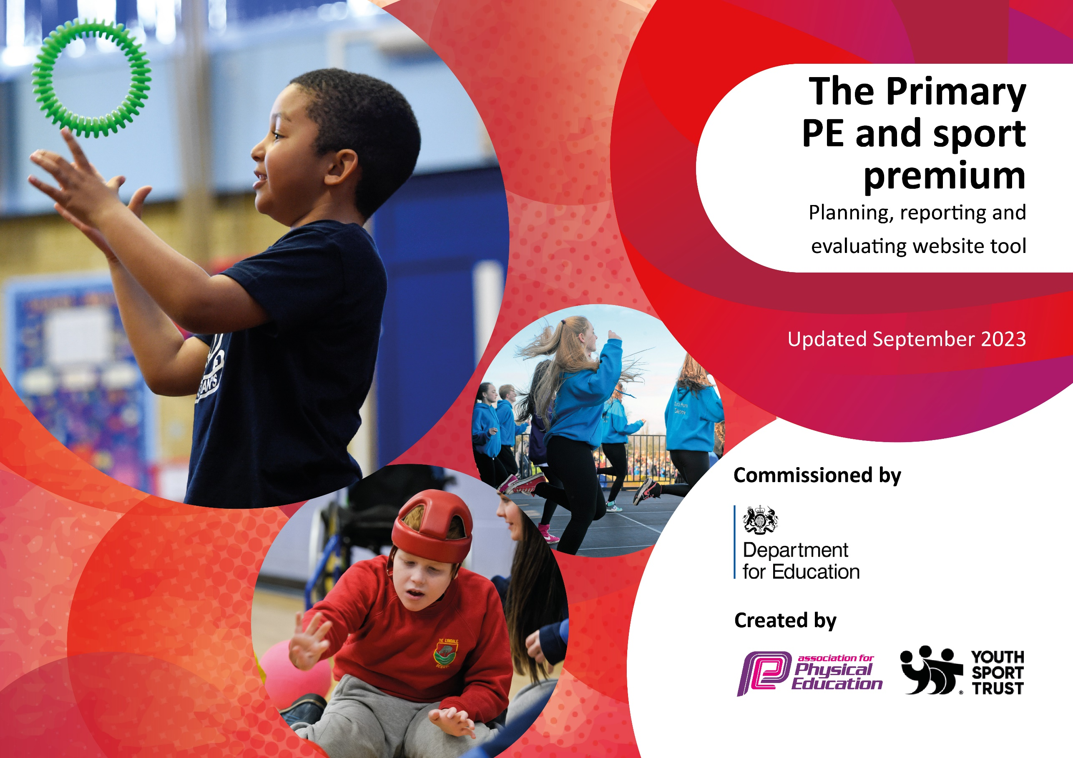

2024

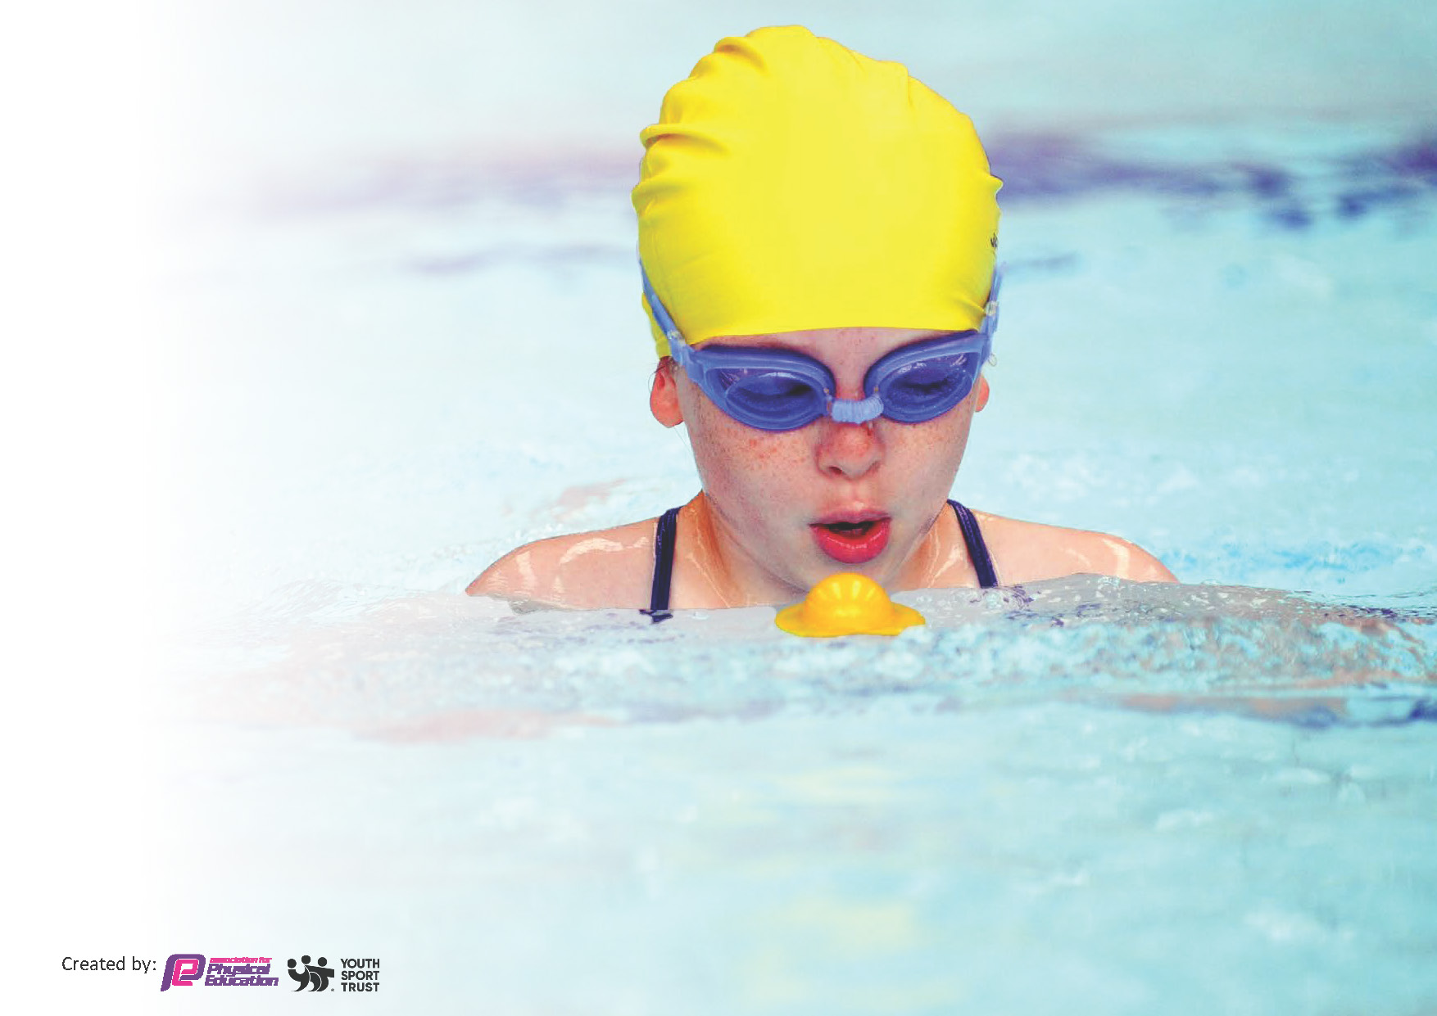
This template can be used for multiple purposes:
by:
- It enables schools to effectively plan their use of the Primary PE and sport premium
- It helps schools to meet the requirements (as set out in guidance) to publish information on their Primary PE and sport premium
- It will be an effective document to support Ofsted inspections enabling schools to evidence progress in Physical Education (PE) and evidence swimming attainment, which forms part of the PE National Curriculum. We would recommend schools consider
the Intent, Implementation, and Impact of any spend, as examined within the Education Inspection Framework.

It is important that your grant is used effectively and based on school need.

Schools must use the funding to make additional and sustainable
improvements to the quality of the PE, School Sport and Physical Activity (PESSPA)
they offer. This means that you should use the Primary PE and sport premium to:

- Build capacity and capability within the school to ensure that improvements made now will benefit pupils joining the school in future years
- Develop or add to the PESSPA activities that your school already offers.

The Primary PE and sport premium should not be used to fund capital spend projects; the school’s core budget should fund these. Further detail on capital expenditure can be found in the updated Primary PE and sport premium guidance.

The Primary PE and sport premium guidance, outlines 5 key priorities that funding should be used towards. It is not

necessary that spending has to meet all the key priorities, you should select the priorities that you aim to use any funding towards.

Although completing this template is not a requirement for schools, schools are required to publish details of how they spend this funding. Schools must also outline what the impact this funding has had on pupils’ PE and sport participation and attainment and how any spending will be sustainable in the future. All funding must be spent by 31st July 2024.

The Department for Education has worked closely with the Association for Physical Education (afPE) and the Youth Sport Trust (YST) to develop this template and encourages schools to use it. This template is an effective way of meeting the reporting requirements of the Primary PE and sport premium.
Review of last year’s spend and key achievements (2023/2024)

We recommend you start by reflecting on the impact of current provision and reviewing your previous spend.

Activity/Action | Impact | Comments
- Installation of Astro on the field  - Participation in the Great Big Dance Off Competition 2024  - Held our first St Rocco’s Elf Run  - Competition Success  - Yoga CPD | Although this was CAPEX spend, the impact on our PE and sport has been huge. It has allowed for all round use of the field, creating more opportunities for more children to be active at lunchtime and allowed a high quality and larger variety of outdoor team sports to be played. It has also meant that more than one class at a time can be outside doing PE.  The final impact has been on the variety and number of sports clubs that we can now offer all year round on the Astro.  We were very lucky to have a member of staff who is a dance teacher plus a parent who is also a dance teacher, who led the 6-week rehearsal schedule for the dance troupe. They performed at the Parr Hall against 13 other schools and finished 6th, but first for Warrington. It was an amazing experience for the children who performed so well, they were asked to perform again at the opening ceremony at Road to Paris.  The whole school participated in a charity fun run at Christmas to raise money for St Rocco’s. The children dressed as elves and were given elf ears and had to see how many laps of the daily mile track, they could do in 15 minutes. We raised £600.  We have competed in a huge range of competitions this year, allowing more children to experience competitive sport. However, our top highlights are:  - 3rd in the Regional Boccia Finals  - Reaching the semi-finals of the Warrington Wolves Rugby 7s  - Winning the lacrosse and orienteering at Road to Paris and runners up in the tennis.  Jen Hoe came and delivered a 6-week yoga programme for all KS2 which included chair yoga for when the hall was in use. It had great impact on all the children, but in particular Year 6 who were taught relaxation tips for exams and techniques to help with sleep. | This has been especially useful for Year 6 as they transition into separate girls and boys PE lessons, allowing two classes to merge for PE.  There was no cost involved to school.  - Both dance teachers were voluntary  - Parents paid for costumes  - We hired the TCAT minibus for transport  Due to the time of year, we did not give out individual sponsorship forms, we just asked for donations. The fabulous amount we still managed to raise was due to our sports council who ran the whole event.  We are still awaiting the results of the Quad Kids athletics.  We already have a whole class set of yoga mats so now teachers feel more confident to lead their own yoga sessions both in PE lessons and in the classroom.

Key priorities and Planning
This planning template will allow schools to accurately plan their spending.

Action – what are you planning to do | Who does this action impact? | Key indicator to meet | Impacts and how sustainability will be achieved? | Cost linked to the action
CPD for Teachers/TAS  - Progressive Sport continues CPD with staff on a termly basis, with a focus on assessment.  - Focus on improving PE delivery in EYFS. Progressive Sport to work with them each week and Beccy Cresswell to come and deliver new fundamentals programme to staff in EYFS. | All teaching staff and TAs who cover PE and all pupils  EYFS staff and pupils | Key Indicator 1: Increased confidence, knowledge, and skills of all staff in teaching PE and sport. | Staff are more confident to deliver effective PE, supporting pupils to undertake extra activities inside and outside of school.  PE Monitoring across the whole school demonstrated that teachers have been upskilled due to the CPD, however it was evident that some staff had not regularly led their sessions and that this was only a recent change. CPD should continue to encourage teachers to confidently lead a full lesson next year. | Progressive Sport  £14,000  WASSP £2800

Re-Introduce the daily mile at lunchtime to increase the range of lunchtime activities  Sports Council initial focus is to re-introduce the daily mile at lunchtime with the help of sports leaders and MDAs.  Introducing new sports and activities at GSP.  - Introduction of Trikidzs to all children in KS1 & KS2 in Spring 2025.  - Paddle Tennis to be introduced across KS2  - Introduction of our first ever ‘Colour Run’ in the summer term.  - Progressive Sport Summer Sports Festivals – an opportunity to introduce a range of new sports  - Joe Philbin from Warrington Wolves to tell his story.  Achieve the Tasty Tuck Award 2025.  We aim to do this by introducing more healthy snacks at breaktime and only allowing fruit and vegetables to be brought in from home.  Competitions:  Autumn Term  - Walton Gardens Cross Country Championships  - Primary Ability Day  - Boccia Tournaments  - Liverpool FC Football Tournament KS2 (cancelled)  - Sports Hall Athletics  Spring Term  - Year 5/6 netball tournament  - Warrington Wolves Tag Rugby Festival  - Cheshire Fire 7s 1st round  Summer Term  - GBDO 2025  - Culcheth Cross Country  - Bale Races  - QuadKids Athletics  - Road to Glasgow | MDAS / Sports Leaders / Sports Council.  All pupils – as they will take part  KS1 & KS2  KS2  Whole School  Whole School  Reception and Year 6 children  Whole school  All chn in cross country club, from Year 4-6 invited.  7 SEND children  Netball Team  All LKS2 chn  10 Year 5/6  28 children  16 children  16 children  16 children  40 children | Key Indicator 2 – The engagement of all pupils in regular physical activity – 30 mins a day within school.  Key Indicator 3 – Raise the profile of PESSIPA  Key Indicator 4 – Broader experience of a range of sports and activities offered to all pupils.  Key Indicator 3 – Raise the profile of PESSIPA  In addition, supports the NC aims of children leading ‘healthy, active lives.’  Key Indicator 5 – Increased participation in competitive sports. | Sports council have met throughout the year, with some meetings specifically about the new planned daily mile track and how it will be introduced and monitored to ensure it is used regularly by all children. The daily mile track is not yet installed, so we will continue with this to promote it once this happens.  All children from Year 1 – 6 as well as staff participated in our first Triathlon circuit which included resistance band swimming, stationary cycling and a running circuit. It was a huge success, inspiring MDAs to also run out and join in! We have now agreed to make it an annual event at GSP.  Progressive Sport Summer Sports Festival to happen during Active Kids week, where all children get to experience archery, boxing, and golf. Ellie also ran outdoor yoga sessions for KS1 and UKS2 to ensure we incorporated mindfulness and meditation into our active week. We also started each day with a ‘Wake Up’. Shake Up’ session that was well received and will now be an annual part of Active Kids week!  Jo Philbin came in during our ‘Hopes and Dreams’ week to talk to children about his journey to becoming a professional rugby player and then he showed the children some rugby skills.  Unfortunately, we did not get to try paddle tennis or run a colour run due to being inhibited by cost.  We have seen a huge move in the right direction regarding the number of children who now bring in fruit or vegetables from home, particularly in KS1. However, it was decided that we were not going to remove unhealthy snacks from those children who still chose to bring them in, so we will be unable to apply for our Tasty Tuck Award.  Excellent success in cross country races with 3 children finishing in the top 10. (Matthew, Autumn, and Poppy.) Poppy also received a medal for finishing 3rd. We also had a lot of children compete for the first time!  We only took 7 children to Primary Ability Day where they tried multi-sports, table cricket, Boccia, and wheelchair rugby. On the back of this our Boccia team was selected and played in the Warrington tournament, which we won! They are now competing in the county finals on 7th March. We won the county finals so have now progressed to the regional finals in the summer.  They really enjoyed the regional final but did not make it out of the group stages.  15 children competed in the sports hall athletics for the first time. We did not qualify for the next round, but it was a wonderful experience for all the children involved.  7 children competed in the netball competition, and we finished second, so now we have passed to the next round in March.  We competed in the first round of the Rugby 7s but unfortunately got knocked out in the semifinal. However, we also took 30 children to the Warrington Wolves tag rugby festival and won all our games!  Our dance troupe competed in the GBDO 2025 and finished 11th. They also performed at the TCAT festival and summer festival.  We had 16 children competing in the Culcheth Cross Country with Matthew B finishing 4th and Ffion L finishing 9th. We also competed for the second year in the Bales Races.  16 children competed in Quad Kids, and we came 5th..  We took 40 children to the new Road to Glasgow festival who competed in Quad Kids, lacrosse, and cricket. However, we did not feel the children benefited from this experience, so we will review it moving forward. | No cost  No Cost  Progressive Sport £500  No cost  No cost as all included in WASSP membership  Possible Coach Hire  £1000  (We use cars or minibus when possible

Key achievements 2024-2025
This template will be completed at the end of the academic year and will showcase the key achievements schools have made with their Primary PE and sport premium spending.

Activity/Action | Impact | Comments
1.Introduction of Trikidz Triathlon Training  2. Use of our Progressive Sports Coach  - A review of our whole school sports day | All children from Year 1 –6 got to experience the events in a triathlon, i.e. running, swimming stimulation and cycling. KS1 was about learning the skills and then KS2 progressed to adding in competition. It was one of the most positive PE experiences this year, and we are now committed to making it an annual event.  Ellie has been a welcome introduction to our school this year and has delivered some excellent CPD for our staff. She has ensured that there is a high level of PE now delivered from EYFS all the way through both key stages. She also made a massive contribution to our ‘Active Kids’ week with her delivery of ‘Wake Up Shake Up’, Sports Festivals and outdoor yoga.  Following the Sports Council suggestions, we introduced ‘Wake Up Shake Up’ vortex throw, triple jump, bouncy hopper bean bags and a parents V staff tug of war. All were well received so will now be a permanent change to sports day. | No cost as run by a charity  Most of our PE budget was used to fund Ellie so we have reduced her to one day a week next year to free up more sports premium to invest in other areas.  We will continue to look for ways to improve sports day with maybe a coffee van and whole school picnic next year.

Swimming Data
Meeting National Curriculum requirements for swimming and water safety.
Priority should always be given to ensuring that pupils can perform safe self-rescue even if they do not fully meet the first two requirements of the National Curriculum programme of study

Question | Stats: | Further context  Relative to local challenges
What percentage of your current Year 5 cohort can swim competently, confidently and proficiently over a distance of at least 25 metres? | 95%
What percentage of your current Year 5 cohort can use a range of strokes effectively [for example, front crawl, backstroke, and breaststroke]? | 95%

What percentage of your current Year 5 cohort are able to perform safe self-rescue in different water-based situations? | 95%
If your schools swimming data is below national expectation, you can choose to use the Primary PE and sport premium to provide additional top-up sessions for those pupils that did not meet National Curriculum  requirements after the completion of core lessons. Have you done this? | No
Have you provided CPD to improve the knowledge and confidence of staff to be able to teach swimming and water safety? | No

Signed off by:

Head Teacher: | (Name)
Subject Leader or the individual responsible for the Primary PE and sport premium: | (Name and Job Title)
Governor: | (Name and Role)
Date:

