
Great Sankey Primary School

Liverpool Road,
Great Sankey
Warrington
WA5 1SB

Headteacher: Mrs V.J Briggs BA (HONS) QTS NPQH

Telephone: 01925 728176
Email: admin@greatsankeyprimary.warrington.sch.uk
Website: https://greatsankey-warrington.secure-dbprimary.com/warrington
Twitter: @GtSankeyPrimary

Together We Learn and Grow’

Friday 29th May 2020

Year 6 Re-opening

Dear parent and carers

This letter aims to outline the details and routines for your child that we have put in place. We appreciate that you or child may feel anxious with the return and hope that this information will support in reducing this.

Year 6 Groups:

Your child is in GROUP ONE

Group 1 | Monday through to Thursday  Start time 9.30am and end time 3.30pm
    Mr Gawne Miss Leah |  | 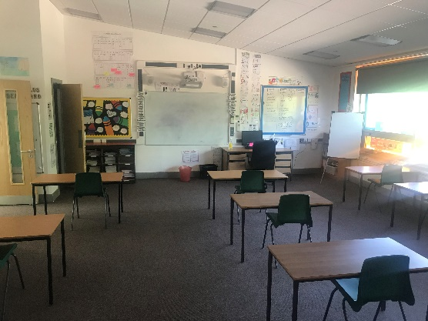  Situated in Elder tree class

Group 2 | Monday through to Thursday  Start time 9.30am and end time 3.30pm
    Mrs Williams Mrs Culverwell |  | 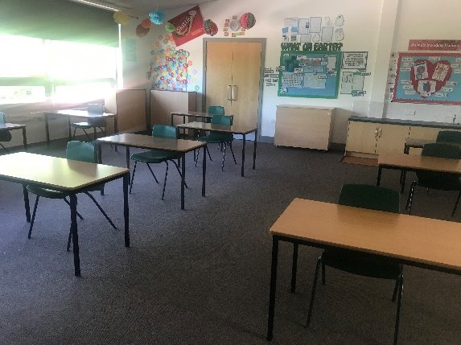  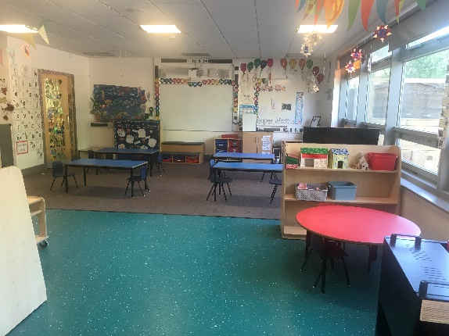  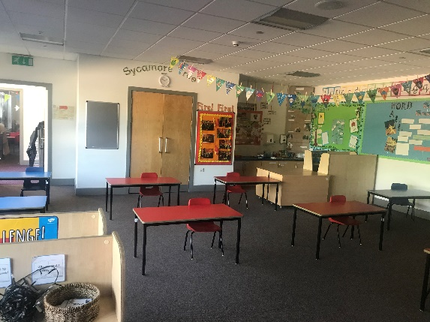  Situated in Oak tree class

Group 3 | Monday through to Thursday  Start time 9.20am and Collection 3.20pm
    Mr Ellis Mrs Gibson |  | Situated in Pine tree class

Drop off and collection times:

We have carefully considered all the options for dropping off and collecting the children across the allocated year groups. We are requiring parents to follow all the guidelines strictly to support in keeping staff, children and parents safe. Only one adult per child will be allowed onto the school premises at drop off to keep numbers at a minimum for the year six children.

It is important that you only come at your allocated time. Unfortunately, due to the tight timings of groups of children arriving, and to support in minimising large gatherings, we will not be able to accept children outside of the times shown. Whilst we appreciate that occasional lateness can be unavoidable, at this time, safety for all is our priority and we hope you understand and support us with this.

Parents will be asked to drop their child off at the green gate outside the main hall door, although after a few drop offs we are encouraging Year Six children to walk down the red path on their own if they feel confident to do so. Members of staff will be on hand to guide and support your child into school. Due to restrictions on social distancing, we will only be able to offer words of comfort and encouragement, should a child be upset at leaving parents on drop off. We strongly advise that you talk to your child about the new interim arrangements to help them begin to adjust during this period.

Collection:
As year six children are older and we are trying to build independence ready for high school, we are asking that all year six parents wait outside the main school gates, maintaining social distancing in an agreed place along the roadside. Children will leave at their allocated group time and join our one-way system to exit the grounds safely. Members of staff will be around the school grounds to support with this.

If you DO NOT wish to take up the allocated place please email admin@greatsankeyprimary.warringtonsch.uk by midday on Tuesday 2nd June 2020.

Thank you for your continued support and we look forward to seeing you on Monday 15th June.

Kind regards
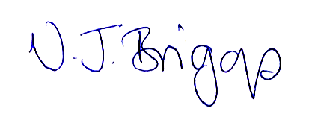

V.J. Briggs
Headteacher

