
Great Sankey Primary School

Liverpool Road,
Great Sankey
Warrington
WA5 1SB

Headteacher: Mrs V.J Briggs BA (HONS) QTS NPQH

Telephone: 01925 728176
Email: admin@greatsankeyprimary.warrington.sch.uk
Website: https://greatsankey-warrington.secure-dbprimary.com/warrington
Twitter: @GtSankeyPrimary

Together We Learn and Grow’

Friday 29th May 2020

Year 1 Re-opening

Dear parent and carers

This letter aims to outline the details and routines for your child that we have put in place. We appreciate that you or child may feel anxious with the return and hope that this information will support in reducing this.

Year One Groups:

Your child is in GROUP ONE

Group 1 | Monday through to Thursday  Start time 9.10am and Collection 3.10pm
      Mrs Walley Mrs Franklin Mrs Pearson |  | 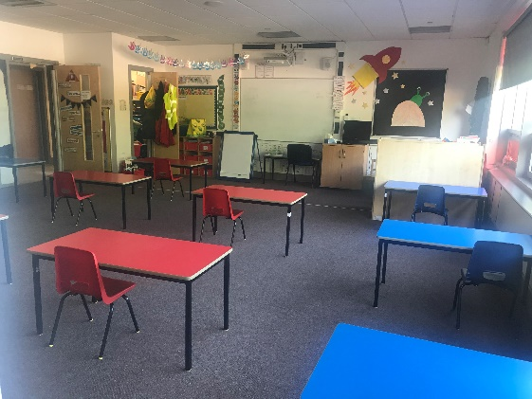  Situated in Maple tree class

Group 2 | Monday through to Thursday  Start time 9.10am and Collection 3.10pm
    Mrs Moore Miss Pilkington |  | 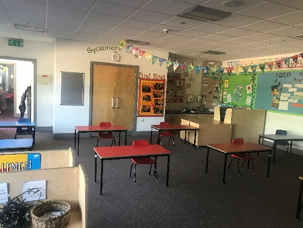  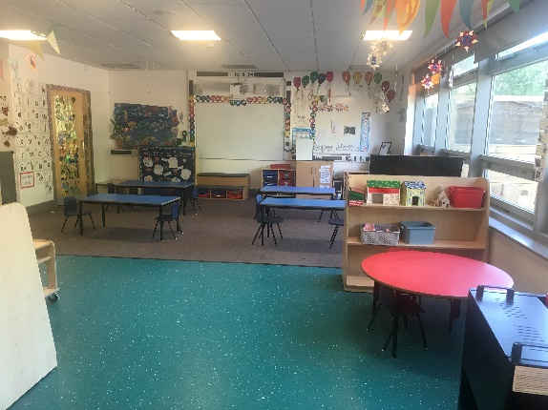  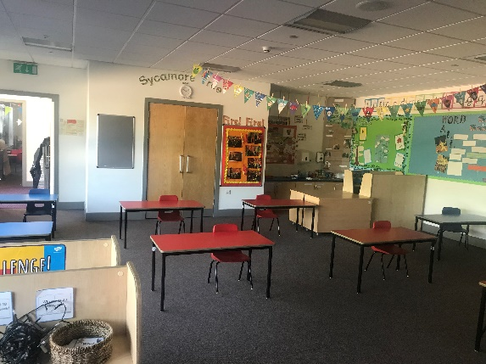  Situated in Sycamore tree class

Group 3 | Monday through to Thursday  Start time 9.00am and Collection 3.00pm
    Mrs Wrangles Mrs Christopher |  | Situated in Willow tree class

Drop off and collection times:

We have carefully considered all the options for dropping off and collecting the children. We are requiring parents to follow all the guidelines strictly to support in keeping staff, children and parents safe. Only one adult per child will be allowed onto the school premises at drop off and collection to keep numbers at a minimum.

It is important that you only come at your allocated time. Unfortunately, due to the tight timings of groups of children arriving, and to support in minimising large gatherings, we will not be able to accept children outside of the times shown. Whilst we appreciate that occasional lateness can be unavoidable, at this time, safety for all is our priority and we hope you understand and support us with this.

Parents will be asked to drop their child off at the green gate outside the main hall door. You will not be permitted to go past the gate at this time. Members of staff will be on hand to guide and support your child into school. Due to restrictions on social distancing, we will only be able to offer words of comfort and encouragement, should a child be upset at leaving parents on drop off. We strongly advise that you talk to your child about the new interim arrangements to help them begin to adjust during this period.

Collection:
Year one parents are asked to wait in the usual area within the playground, maintaining social distancing. Posters are displayed to encourage and remind you of this. Children will leave at their allocated group time via the normal key stage one external doors. Parents are asked to join the one way system and follow the red path on the playground to then exit around the back of the school. This will be clearly labelled with arrows to indicate the direction of the one way system. We encourage the parent to leave the school promptly.

If you DO NOT wish to take up the allocated place please email admin@greatsankeyprimary.warringtonsch.uk by midday on Tuesday 2nd June 2020.

Thank you for your continued support and we look forward to seeing you on Wednesday 10th June.

Kind regards
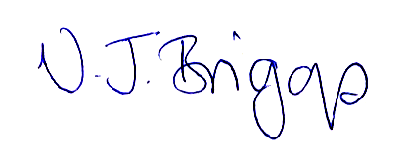

V.J. Briggs
Headteacher

